Introduction to the project and workorder portfolios in UBW

The purpose of this document is to give a general introduction to the portfolios “Min prosjektportefølje” and “Min arbeidsordreportefølje”. Each of these menu items can be found under the “Prosjekter” tab on your personalized UBW Web homepage.
Indented user groups
Registered managers on UBW projects or workorders. While the portfolios are intended primarily for projects with external funding, internally (NMBU) funded projects are also included.
Income and Costs
Income (external grants or own effort funding) are shown as red minus amount
Cost are shown as black amount
When the cursor hovers over the menu Project (do not click), the submenu appears:
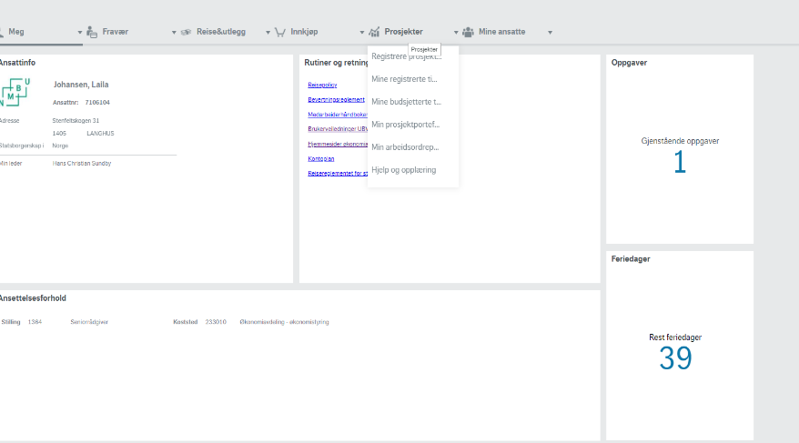
By selecting the menu item «Min prosjektportefølje», an overview showing all projects to which you are registered as a project leader, will appear. By selecting «Min arbeidsordreportefølje», an overview showing all workorder you are registered as a workorder leader, will appear.
A project is composed of one or more workorders. One workorder equals one work package. Work packages can be helpful and allow for better control in managing complex projects. Simple projects may only need the minimum of one work package (workorder), e.g.:

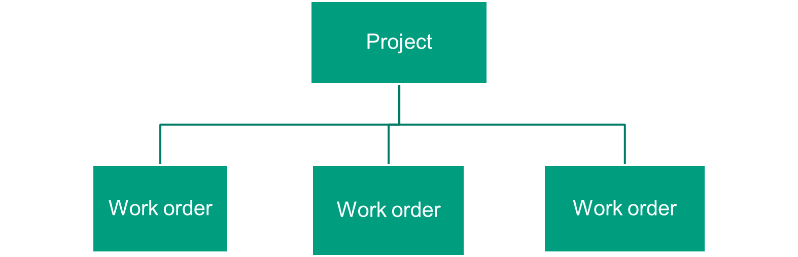

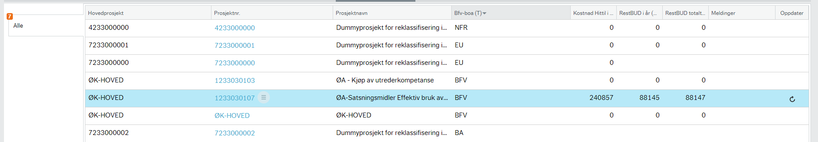

Column text explanation
BFV-BOA (T): Project type. BFV= internal funding, EU= funded by the European Commission, NFR= Funded by the Research Council of Norway (RCN), OA= commission projects (“oppdrag”), BA= contribution projects (“Bidrag”) other funding than EU or RCN.
Kostnader hittil i år: Costs so far this year. (Only including expenses booked to the accounts; not including invoices or timesheets in workflow). Please note that the column only shows the faculties own expenses.
Restbudsjett i år: This year’s remaining budget. It means this year’s total budget reduced with the posted costs so far this year. If the total budget for this year was 1.500.000 NOK and the posted costs are 500.000 NOK, you have 1.000000 NOK left to use this year. Please note that the column only shows the remaining budget of the faculty’s own expenses.
Restbudsjett totalt: Shows what you have left of the project’s total budget for the rest of the project’s lifetime. If the total budget from this year’s start to the projects end is 3.000.000 NOK, and the posted costs are 500.000 NOK, the total left to use for the remaining years are 2.500.000 NOK. Please note that the column only shows the remaining total budget of the faculty’s own expenses.
Meldinger: Various alerts, and specifically:
Red circle and text «Ikke bokførte fakturaer»: one or more invoices currently in the workflow and not posted to the accounts. Unposted invoices are not included in financial reports.
Red circle and text “Ikke bokførte timer”: Timesheets (registered hours) currently in the workflow and not posted to the accounts. Unposted timesheets are not included in financial reports.
Red circle and text “Restbud i år”: Alert issued when 90% or more of this year’s budget is used
Yellow circle and text “Restbud i år”: Alert issued when 80% and up to 90% of this year’s budget is used
If any of these alerts appear, so will a check box to the far left. By clicking one of these boxes, e.g. “Ikke bokførte fakturaer”, you can view a list of only the projects to which this alert applies. By clicking the box “Alle”, you return to the full view of projects/work orders.
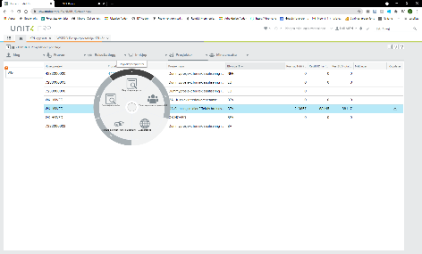
Use the wheel next to each project number, to drill down to various reports. Please note: Click on the arrow on the outer rim to select a report.

By clicking on the project or work order number, you enter a dashboard showing key information. From this dashboard it is possible to choose various reports in the menus on the top. These reports are identical to those available in the “wheel” from the main portfolio site.
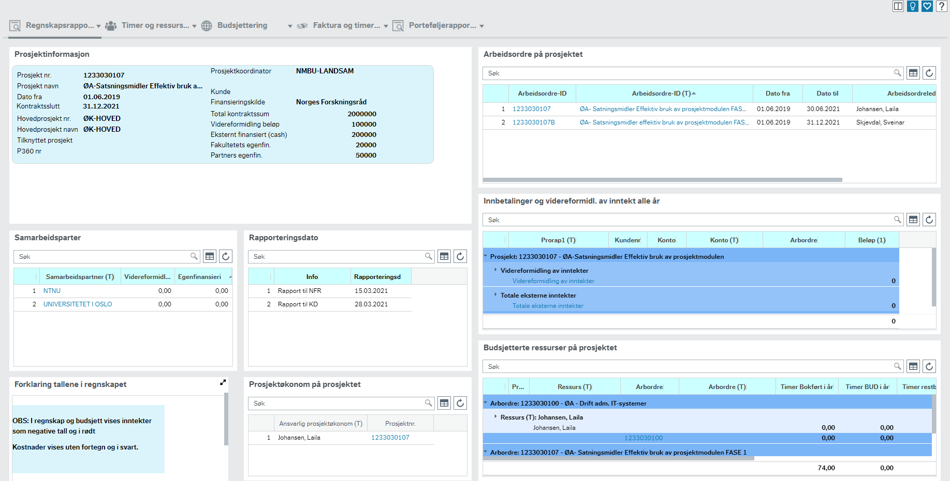

Financial report column headings:
Reports can be access either 1) through the wheel in the main portfolio site, 2) through the top menu of the individual project’s or work order’s dashboard. 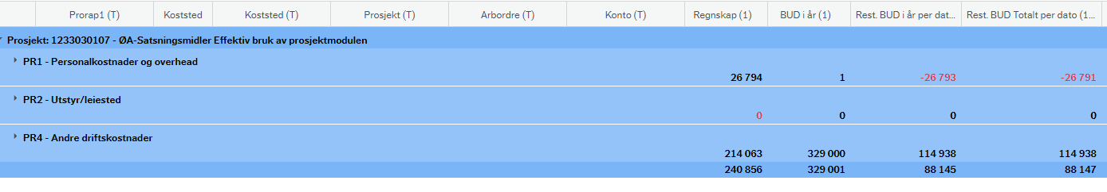
Regnskap: This column shows the posted expenses and income* so far this year. Please note that any invoices or timesheets not yet posted (workflow) will not be included.
(*Income means external grants or own effort funding.)
BUD i år: This column shows the total budget for this year.
Rest.BUD i år per dato: This column shows this year’s remaining budget. Specifically, this year’s total budget minus booked income and expense so far this year.
Rest BUD Totalt i pr per dato: This column shows what you have left of the project’s budget for the rest of the project’s lifetime. For internally (NMBU) funded projects (projects starting with the digit 1), this column will show the same amount as “Rest. Bud i år per dato» because these projects receive funding for one year at a time. In contrast, externally funded projects receive funding for the total lifetime of the project at once. The column will show the total budget for this current year and the years to come, reduced with expense and income booked so far this year.
Please refer to the videos in the menu item: Hjelp og opplæring under Prosjekter

