Payment of holiday pay is on 12 June. Experience has taught us that there are many questions concerning the calculation and payment of holiday pay.
The number of vacation days deducted from your salary is equal to the number of paid vacation days to which you are entitled. 5 weeks holiday (6 weeks for those over 60 years old) is deducted from your salary in June. Full holiday entitlement (25 workdays, 30 days for those over 60 years) exceeds one monthly salary (which is approximately 22 workdays), leaving a negative net amount on the June salary. Holiday pay is based on a full year’s employment the previous year, which covers a deduction of 5/6 weeks, resulting in a gross amount for June that is usually higher than your regular gross monthly salary amount. In accordance, no tax is deducted from the holiday payment, which means that the net amount in June will be considerably higher than a regular monthly salary.
Following is an example of the calculation of holiday pay in June for an employee with a full year’s employment the previous year:
Gross amount salary June: 38 750
Holiday pay earned previous year (450 751 x 12%) 54 090
Deduction of 5 weeks’ vacation (monthly salary June x 12 months/52 weeks x 5 weeks) 44 711
(38 750 x 12/52 x 5)
Gross amount in June: 48 129
Holiday pay in June (holiday pay basis 450 751 x 12% = 54 090.20), deduction 5 weeks = 44 711.53
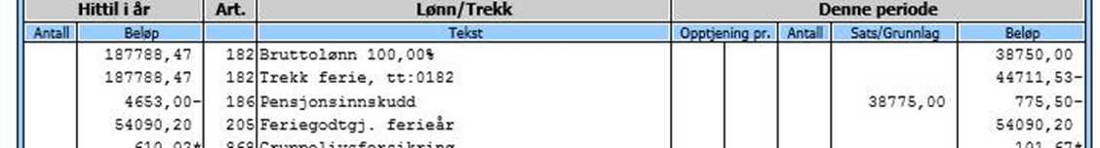
12 months holiday earning and basis from December payslip (2015):
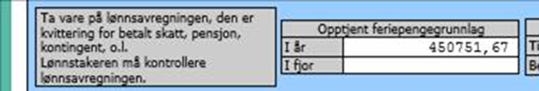

Employees over 60 years old:
Persons older than 60 years or who fill 60 years during the holiday year are entitled to an extra week’s vacation. Thus 14.3% of the holiday pay earned in the previous year is paid out and the number of vacation weeks deducted will be 6 weeks in June.
(Senior days are not vacation days and are deducted on a separate code in Paga Web – this must be followed up locally).

Change in full-time/part-time employment:
Persons with a higher percentage of employment in June this year than the average for 2015, will be deducted any negative holiday pay supplement, as the cost of vacation days in a higher percentage of employment is more expensive. The alternative is to reduce the number of vacation days.
New employees or employees without full vacation days earnings in 2015 who would like to take vacation
The employee’s personnel officer or leader must notify the Payroll Section by email on the number of vacation days requested (does not apply for vacation days that the Payroll Section are already aware of through the forms sent out in May concerning employees without full vacation days earnings). The Payroll Section will deduct the number of days from the salary and amend the vacation account in Paga with the correct number of days.
All employees have a duty to register their vacation in Paga Web.
New Certificate of pay and tax deducted (“Årsoppgave”) from 2015:
After the implementation of the “A-Ordningen” 01.01.2015, the Certificate of pay and tax deducted that is sent to employees was changes. The Certificate from Paga (Bluegarden) was changes on The Norwegian Tax Administration’s (“Skatteetaten”) recommendations, but the text can easily be misunderstood. On the Certificate is shown “Calculated holiday pay for payment next year” (“feriepenger beregnet for utbetaling neste år”), see example below. This amount is 12 % (14,3 % for employees older than 60 years) of the holiday pay basis (“feriepengegrunnlag”) in 2015, and it is not the amount that the employee will receive on the June salary in 2016 (see calculations in the example above).
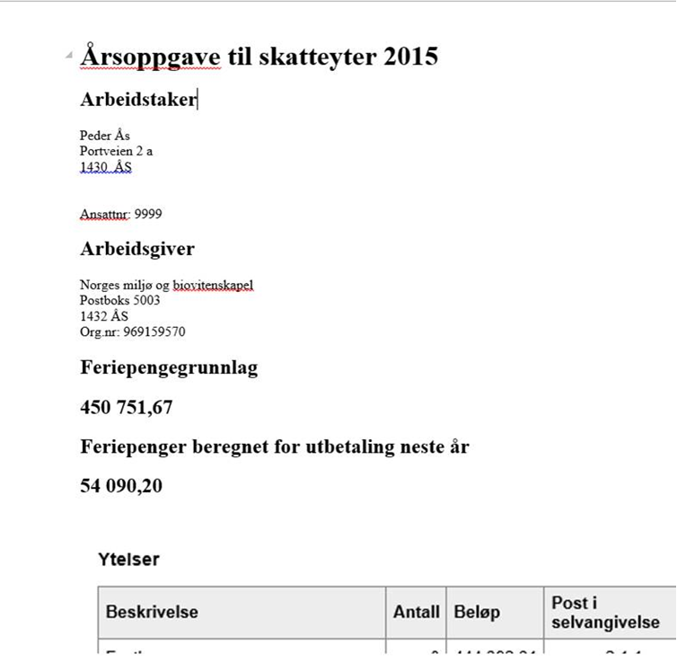
Kind regards from the Payroll Section
Jeremiassen, Line Bøe | 67230603 | Head of section | Payroll
Berg, Kirsten Ranheim | 67230608 |  | Payroll
Johannessen, Johnny | 67230606 |  | Payroll
Nerdrum, Margareth | 67230625 |  | Payroll
Pedersen, Janne Elisabeth | 67230609 |  | Payroll
Setten, Harald | 67230611 |  | Payroll
Mai Britt Wiig +4767230630

