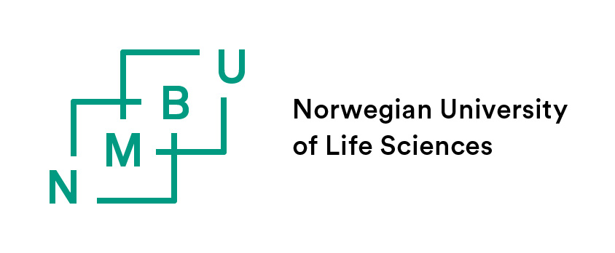
Non-degree studies, Bilateral or Nordplus
Erasmus students, please use the application form for Erasmus exchange

Norwegian University of Life Sciences (NMBU)  Admission Office  P.O. Box 5003  N-1432 Aas  Norway  Fax: +47 6496 6021 | Deadlines for application are:  March 1. for the Autumn semester (begins August), including a priority for accommodation if accepted.  October 1. for the Spring semester (begins January)

Name student:
Academic Year: /
When do you intend: a. to begin your studies at NMBU (dd mm yy) - -
b. to end your studies at NMBU (dd mm yy) - -

DETAILS SENDING (HOME) INSTITUTION
Name of University:
Country:
Contact person (exchange coordinator) sending university:
E-mail address:

PERSONAL DATA
Family name:
Given name(s):
Date of Birth: - - | Place of Birth:
Nationality: | Sex:
Current Address:  Tel: + | Contact Address (if different):  Tel: +
E-mail:
I am coming to NMBU through the following programme:
Bilateral Agreement: ( ) Nordplus: ( )
Other, please specify:

STUDY PROGRAMME AT HOME INSTITUTION
Diploma or degree for which you are currently studying:
Main subject, field or major of degree/diploma:
Number of years of study so far: years BSc years MSc other (specify)

LANGUAGES
Mother tongue: Other languages:
Please note that your level in English language needs to be sufficient in order to be able to attend courses. The requirement for exchange students is regulated by the current exchange agreement between NMBU, otherwise TOEFL score of 500 or equivalent is required.
 | English writing  Reading  Speaking |  | Sufficient  Sufficient  Sufficient | Good  Good  Good | Very Good  Very Good  Very Good

COURSE SELECTION AT NMBU
Please select 50-60 ECTS per semester in case courses are full or the applicant does not meet the pre-requisites. Courses should be listed in order of preference.
Course code | Course title (as indicated in the course catalogue) | Semester | Number of ECTS credits

COURSES CURRENTLY ENROLLED IN AT HOME UNIVERSITY

Course title | Course content | Number of ECTS credits

CHECK LIST (Without these document the application will not be taken into consideration)
All documents can be sent by email by the applicant’s sending (home) institution.
I have enclosed transcript of my university records
I have enclosed an overview of my academic program, including courses I am currently enrolled in.
I have enclosed a copy of passport (the pages with name, photo ands expiry date)
I have familiarised myself with the immigration process (www.udi.no)
I will need accommodation and understand that: - Accommodation can only be booked from the beginning of each semester. This means that I will be required to pay rent from either August 01 or January 02 even if I arrive later. The minimum contract period is 3 months.

I hereby confirm that the above information is correct. I understand that admission to the Norwegian University of Life Sciences as an exchange student is for maximum one year only and does not constitute admission to any regular degree programme.

____________________________ ________________________________________
Place and date Signature

