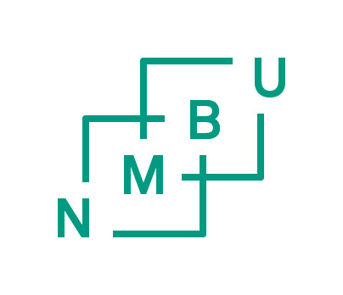

Memorandum of Understanding
between
XXXX
and
the Norwegian University of Life Sciences (NMBU), Norway

This Memorandum of Understanding (MoU) between XXX and the Norwegian University of Life Sciences (NMBU) is intended to facilitate a collaborative programme of research, training, curriculum and institutional development, dissemination of information and exchange of faculty, students and staff. The MoU will cover a five (5) year period and may be extended for additional five-year periods by mutual agreement. The MoU may be terminated by either university upon six- month written notification to the other institution.

The XXX University and the Norwegian University of Life Sciences agree to facilitate, where financially feasible, long-term and short-term exchanges of faculty, students and staff. Sabbaticals, faculty improvement leaves, visiting professorships, research collaboration and other activities may be added when developed and approved by the two institutions.

The collaboration may involve programmes relating to research, teaching, and outreach. It may involve any discipline to the extent that individuals are able to locate suitable counterparts at the other institution. The partners’ aim is to enter into institutional agreements regarding specific programmes once the necessary funding has been secured.

Office space and academic facilities provided to visiting faculty members may vary. The respective faculties in consultation with visiting faculty members will make such arrangements.

The specific details of each activity shall be recorded in writing prior to implementation and shall be governed by a supplementary agreement. Prior to finalizing individual visits, representatives at both institutions shall secure approval from their respective department heads or deans, and designated university administrative officers.

Students may be admitted to academic study with term(s) of attendance, academic eligibility and course of study determined individually for each student by the two institutions. Admission will follow the ordinary rules and requirements at the partner universities.

Specific Terms of Agreement (ToA) providing for transfer of information, faculty, staff and students for education, research or related activities will be proposed by the two institutions through their respective faculties and units, in consultation with recommendation and designated concurrence by the appropriate offices.

For conditions not covered by this Memorandum of Understanding or for problems that arise, both parties agree to refrain from unilateral action and to consult and negotiate mutually agreeable decisions.
All institutions involved undertake to respect and promote human rights in accordance with their international obligations. The institutions will promote equality of individuals involved or affected by the programmes, and will not discriminate on the basis of race, sex, ethnicity, religion, or other characteristic.

XXX Norwegian University of Life Sciences
(NMBU)

Name date
Title
Curt Rice date
Rector

