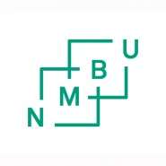
NEW ASSESSMENT – DEGREE THESES
(following a complaint against an assigned mark)
Please read NMBU’s guidelines for examiners and marking Academic Regulations for NMBU.

Examinee
Examinee name:
Date of birth:
Student number:

Title of degree theses:

New assessment:
Final mark:
Mark assigned by internal examiner:
Mark assigned by external examiner:

Signature:
 | Date: | Signature:
Examiner (internal)
Examiner (external)

