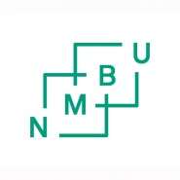
ASSESSMENT PROTOCOL FOR

SPECIAL SYLLABUSES

When completed and signed the form must be sent to sensur@nmbu.no

STUDENT
Student name
Student no.
Date of birth
Study programme

SPECIAL SYLLABUSES
Title in Norwegian
Title in English
No. of study point
Faculty
Year and semester
Special syllabus in connection with: | Associated with a master’s thesis. | Associated with a Ph.D. degree | Other special syllabuses
 | ☐ | ☐ | ☐
Assessment | A to F | Pass/ Fail | A to F or Pass/Fail

ASSESSMENT
Pass/ Fail
Letter grade A to F

SIGNATURE
 | Date | Signature
Internal examiner
External examiner

