Updates in kincalc, november 2023:
Professor Bakken saw that when working on very large datasheets with many samples and duplicates/triplicates/quadruplicates, there was a need for time saving measures in calculating averages and standard deviation for the various gas plots and kinetics. He therefore created a new sheet, previously non-existent, in the kincalc spreadsheet where this can be done robustly and fast.
The new sheet, aptly named «Treatment AVG» has been inserted next to the advices sheet:
Within the sheet you can plot the gases for a treatment and all it’s replicates to get a overall overview of the gas measurements or electron flow for that treatment. Depending on wich «Column» you choose from the «Master» sheet, the AVG sheet will calculate the averages and SD for this data, and the sheet produces a gas plot:
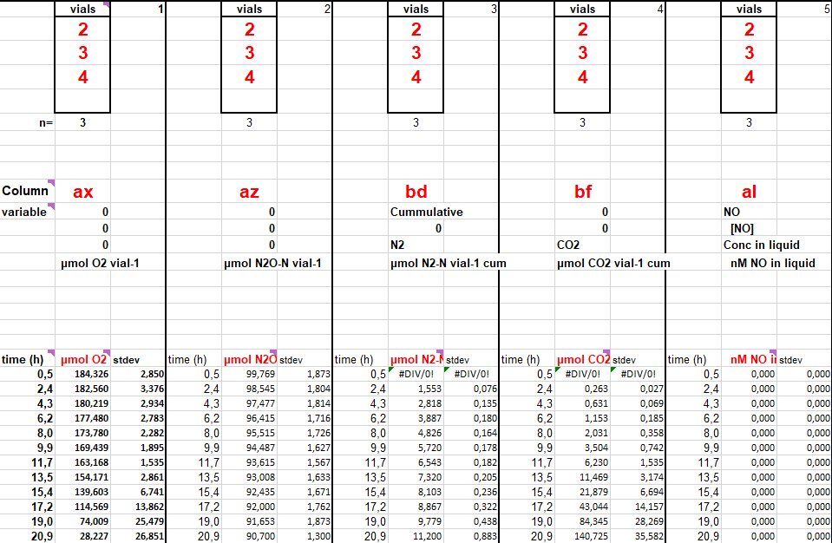
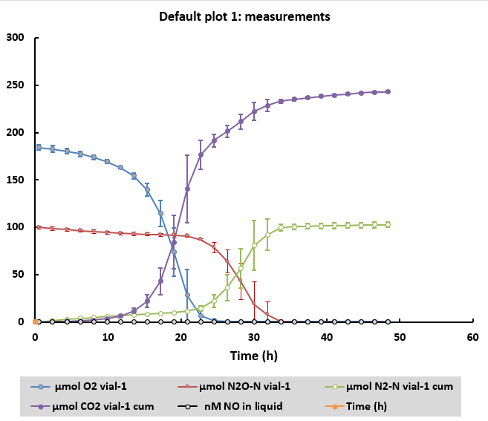

In some cases you might like to compare the same gas for different treatments. For instance, if you would like to see how different treatments consume O₂. Then insert the same «Column» for each treatment and choose the vials:
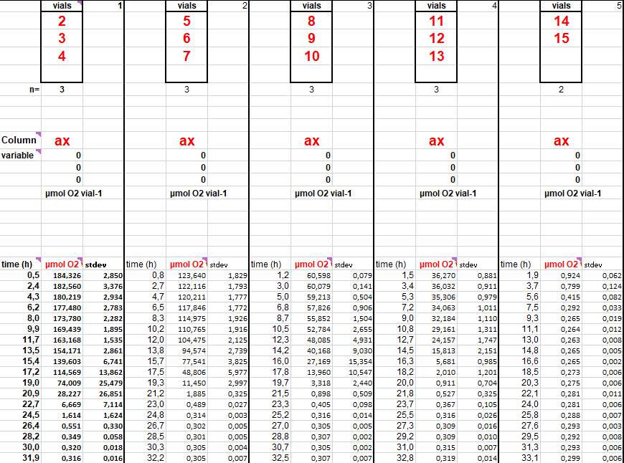
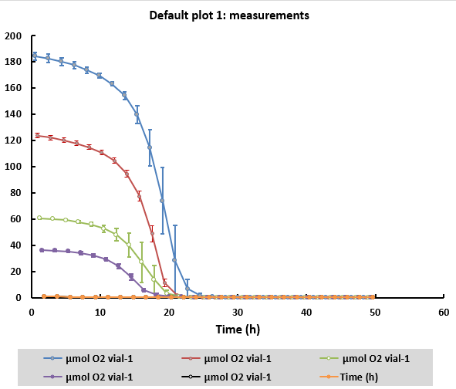

You can choose a minimum of two and a maximum of four replicates for each treatment/gas you wish to look at. The sheet knows how many there are based upon how many «vials» you choose to fill in, if you fill in three vials, «n=» will automatically change to three. DO NOT MANUALLY CHANGE THE NUMBER IN «n=» AS IT WILL MESS UP THE ALGORYTHMS AND CALCULATIONS IN THE SHEET, ONLY FILL IN YOUR VIALS. For example, vials 2, 3 and 4 make up one treatment with three replicates, whilst another treatment only has two replicates from vial 5 and 6:
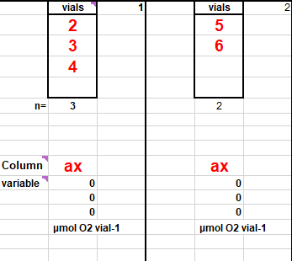
Sometimes you might run the incubation robot with many treatments over a longer period of time, where a new treatment is placed in the incubation robot at a later time. This often saves us from having to create new sequences in the GC program for every day we test a new treatment. So, one treatment might have time 0 as its first sampling point since it was the first sample in a brand new sequence upon starting the experiment. Another treatment that was placed in the incubation robot three days later might then have time 70 as its first sampling point in the gas data. To correct for this so the gas plots for each treatment start at time 0, fill in «time of experiment start» and the time slots will correct automatically in both the plot and average + SD calculations.
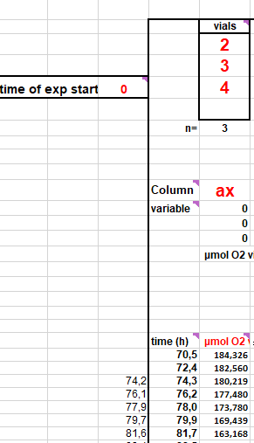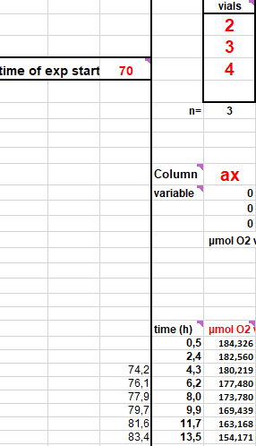

Usually you would like to save the sheet when finished with your calculations and not replace it with new data, maybe because you need the gas plots or for whatever reason. The «Treatment AVG» sheet can easily be copied into the file to make a new tab, or even to older kincalc files to be used there. To ensure that the equations/algorithms of the sheet are not tampered with during copying, you CANNOT simply press CTRL + C and CTRL + V. You have to right click on the tab and choose «Move or Copy».
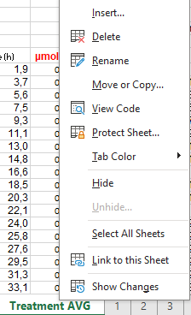
From there you can copy the sheet into any open EXCEL spreadsheet you have on your computer. REMEMBER TO CHECK THE COPY BOX SO THE SHEET IS NOT JUST SIMPLY MOVED OUT OF YOUR SPREADSHEET ENTIRELY.
