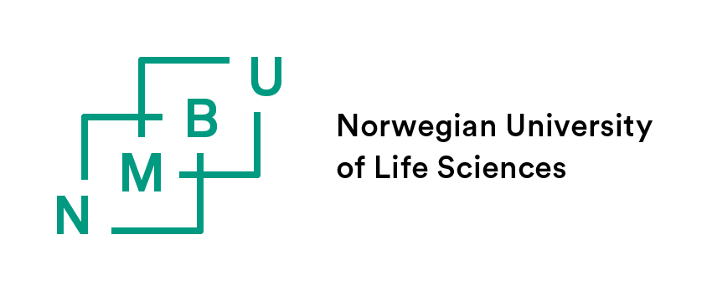
NMBU FORM 3.2 APPLICATION FOR APPROVAL OF COMPLETED COURSEWORK
The PhD candidate completes the form. The main supervisor’s approval is by attaching an e-mail (as a PDF) to this form.
If the information differs from the approved education plan, you can with this form apply for approval of new courses.
The form with its attachments is to be sent by e-mail to the faculty for further processing and approval (https://www.nmbu.no/en/research/contact-persons-during-your-phd).

Course  code | Course name | Institution | Level | Examination  Sem./year | ECTS | NEW | OUT
PHI 401 or similar |  |  | PhD ☐  Master ☐ | S ☐ A ☐ Year | 5 | ☐ | ☐
 |  |  | PhD ☐  Master ☐ | S ☐ A ☐ Year |  | ☐ | ☐
 |  |  | PhD ☐  Master ☐ | S ☐ A ☐ Year |  | ☐ | ☐
 |  |  | PhD ☐  Master ☐ | S ☐ A ☐ Year |  | ☐ | ☐
 |  |  | PhD ☐  Master ☐ | S ☐ A ☐ Year |  | ☐ | ☐
 |  |  | PhD ☐  Master ☐ | S ☐ A ☐ Year |  | ☐ | ☐
Total number of ECTS
Total number of any new ECTS
Total number of any ECTS to be removed
I hereby apply the faculty for approval of the required coursework component described in this table:
ATTACHMENTS (mandatory):
☐ Attach your main supervisor’s approval as a PDF to this form.
ATTACHMENTS (if there are NEW courses in the form):
Courses from other educational institutions than NMBU:
☐ Complete course description incl. information about the type of examination and grading system.
☐ Transcript of records/ course certificates for courses completed at universities outside Norway
Special syllabus at NMBU:
☐ Signed agreement (find template in item 7 at this web page: (https://www.nmbu.no/en/research/forms-phd-education) and course description.

Date and signature:
PhD candidate | Fullt name
Date | Insert date here
Signature | Sending the proposal to the faculty by e-mail replaces handwritten signature.

APPROVAL FROM THE FACULTY:
The approval from the faculty is by the digital approval in P360, in the routine established at the faculty.

Results from Norwegian universities and colleges are transferred to NMBU via the NMBU ‘student data system’ (FS), and it is therefore not necessary to attach transcripts for courses completed at Norwegian educational institutions.

