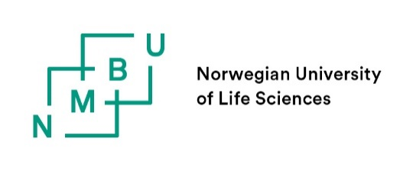
NMBU FORM 2.2.1 Changes to the contract period of a PhD candidate
To be submitted by the PhD candidate if there is a delay and need to change the end date of the PhD education. The main supervisor’s approval of this change can be done by attaching the supervisor’s approval (e-mail or other) as a PDF to this form. Decisions for non-statutory leave must be made on faculty level and those the faculty delegate this decision to.
Send the form and its attachments by e-mail to the generic PhD e-mail address at the faculty (https://www.nmbu.no/en/research/contact-persons-during-your-phd) for further processing and approval.

PhD candidate: | Full name
Faculty: | Select a Faculty
Main supervisor: | Full name
Affiliation:
Current end date: | Old end date
New date for submission: | New date for submission

The delay is caused by |  | Time period (from-to): | % absence from PhD education:
☐ | - Parental leave | From date to date
☐ | - Graded parental leave | From date to date
☐ | - Other leave of absence | From date to date
☐ | - Absence of more than 2 weeks duration, due to illness | From date to date
☐ | - Work on another project | From date to date
☐ | - Other reason: | From date to date
 |  | Describe other reason here

Funding (salary/scholarship, operating funds) during the extension period: | Write your source of funding here
Any project number | Project number

ATTACHMENTS:
☐ Attach the documentation for your leave. Note that documentation is not required for statutory leave such as parental leave etc. However, the information must be sent to the PhD coordinator.
☐ The main supervisor’s approval of the change sent by e-mail may be attached as a PDF to this form.

Date and signature:
PhD candidate: | Full name
Date: | Insert date here
Signature: | Sending the proposal to the faculty by e-mail replaces handwritten signature.

FOR THE FACULTY:
New end date: | Instert date here
Any conditions:
Comments:

APPROVAL FROM THE FACULTY:
The approval from the faculty is by the digital approval flow in P360, in the routine established at the faculty.

