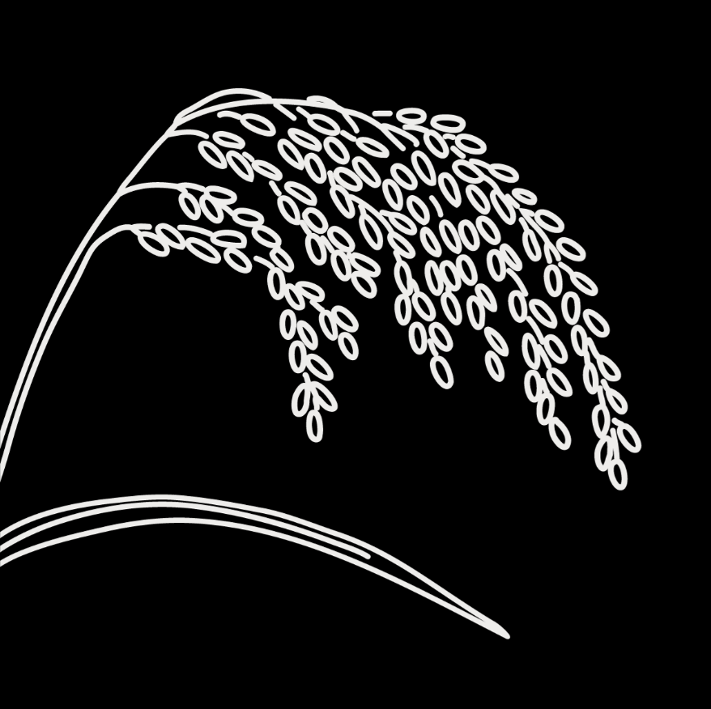
Genebanks and Seed Systems Toolkit
  - KII Checklist #11 – National or international organizations supporting seed systems

Target group: These are guide questions to be used with National NGOs or projects, as well as international agencies working on seed systems in the country like FAO, IFAD, AGRA, etc. The aim is to understand their activities within the seed system, key strengths and weaknesses, and how these are affected by governance and other factors. We also aim to understand their views on seed system development.

The interview should be conducted with one or more organizations’ representatives familiar with the organization’s strategies and seed-related activities.

Introduction
- Explain the objective and obtain consent (fill out and attach the consent form for KIIs)

General information about the organization/agency
- What is the goal of your organization in general? And specifically in relation to seed?
- How long has your organization been working on seed-related issues in this country?

Variety development and management
- Does your organization provide policy, financial, or technical support in crop diversity conservation, plant breeding/variety selection, or variety release/registration?
- What are the objectives of this work, and how is it organized?

Seed production
- Does your organization support any activities related to seed production?
- What are the objectives of this work, and how is it organized?

Seed dissemination
- Does your organization support any activities related to seed dissemination, e.g., emergency seed aid, distribution of new varieties, reintroduction/repatriation of traditional varieties, seed fairs, etc.)
  - What are the objectives of this work, and how is it organized?

Strengths and weaknesses
- Overall, what are the main strengths and weaknesses of your organization’s seed-related activities?

Coordination with other actors
- Who are the main actors you work with for your seed-related activities? (check off all that apply)
- Genebanks
- Plant breeders
- Seed companies
- Agrodealers
- Agricultural extension service providers
- Farmer organizations, e.g., cooperatives and unions
- Individual farmers/households
- Other National or international organizations
- Government agencies/bureaus/offices
- Others (specify):__________________________________
- How well do your interactions/collaborations with these actors function?
- Are there any challenges in coordinating your activities with them?
- How do you think these interactions can be improved?
- Do you work with the national genebank? If so, how?
- Do you have suggestions on how the role of the national genebank can be improved?

Contextual factors
- Which government policies and regulations effectively support your seed-related work? Which ones pose challenges? Please explain.
- Are there local customs, beliefs, or cultural practices that affect your seed-related work? How?
- How does the market/economy affect your seed-related work? Give specific examples.

Recommendations
- Is there anything else you would like to share about your activities or how the seed system is functioning?
- In your view, what are the key issues related to seed in this country?
- Do you have any suggestions or recommendations on how to improve farmers’ access to sufficient, good quality seed of preferred crops and varieties?

