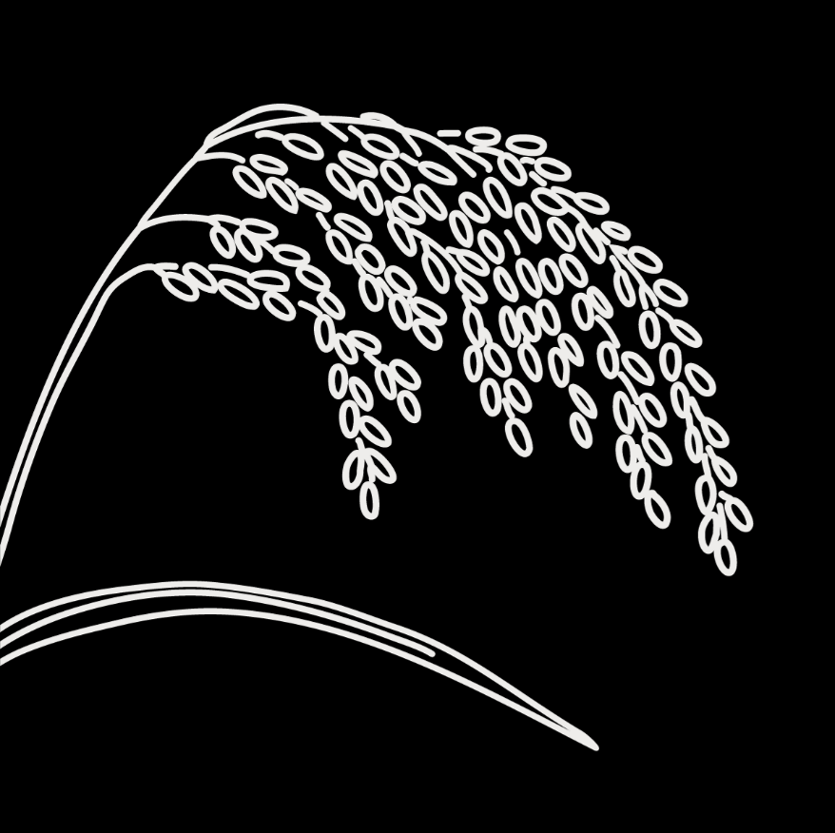
Genebanks and Seed Systems Toolkit
  - KII Checklist #7 – Private and Public Seed Companies/Seed Production Units
Target group: These are guide questions for private seed companies (national or international) and public seed companies/seed production units engaged in seed production and dissemination activities Some seed companies may also run their own breeding programs. The aim is to understand the seed companies’ roles and activities in national seed systems, assess their strengths and weaknesses, and how their activities are affected by governance and other factors. We also aim to understand their views on seed system development.

The interviewer should interview one or a few experts who know the company’s activities within the national seed system and the leadership.

Introduction
Explain the objective and obtain interviewee consent (fill out and attach the consent form for KIIs)

General information about the company
- What is the goal of your company in general? And specifically in relation to seed?
- Can you explain the history of the company?
  - Year of establishment
  - How was it started, by whom
  - Growth of the company
- Briefly describe your current operations
- Total revenues
  - Crops and number of varieties (For key crops: get a list of varieties currently produced/sold)
  - The scale or geographical coverage (local, national, regional, or multinational)

Variety development and management
If the company has plant breeding activities:
- Please describe your plant breeding activities
  - What kind of varieties do you develop (hybrid or OPVs)? Why?
  - What breeding approaches do you use?
  - Which problem does your breeding aim to solve in crop production?
- What is the source of genetic materials you use for your plant breeding?
  - How do you access it, or what are the access conditions?
  - Do you use genebank materials? If yes, which genebank? If not, why not?
- To what extent are the company’s new varieties adopted by farmers? Explain in terms of available varietal traits and farmers’ needs and preferences

If the company produces/sells varieties that are not from their own breeding program:
- How do you obtain new varieties of crops for your business? Explain: varieties obtained in recent years, the sources, the process to obtain them.
- Do you have plans to obtain any new varieties in the future for your business? What traits/types of varieties do you need?

For all companies:
- Does your company have (or is it in the process of obtaining) any plant variety protection (PVP) or patents?
- Please describe: why the PVP was sought, the process/actors involved, where the application was made, which varieties are protected, what rights the PVP/patents give the company.

Seed production
- Which types of seeds do you produce (pre-basic, basic, certified, or all the seed classes)?
- What are the source seeds you use for multiplication, and how do you access them (if not your own)?
- How are your activities organized for seed production? Describe:
  - Land and other inputs you use
  - Seed production activities you outsource
  - Agronomic practices
  - Seed production monitoring and inspection controls for quality
  - Seed certification
  - Seed cleaning/processing and packaging
  - Seed storage processes and facilities
- Do you produce enough seeds that meet the needs and demands of other actors, including farmers? Why/why not? (If possible, fill out the table below for the last three seasons or get EGS production records for filling the table later.)

Table 1. The volume of seeds produced by companies
Year/season (start with the most recent) | Crop | Seed classes | Quantity (Kg)

Seed dissemination
- Who are the users of your seeds? What seed class(es) do they use?
- How do you distribute seed to these users? How do they access your seeds?
- Do you have different channels for different users (specify user)? Explain the difference, for example for:
  - Individual farmers
  - Farmers’ organizations
  - NGOs and other aid agencies
  - Government institutions
- Are there users who cannot access your seeds? If yes, which ones, and what are the reasons?
- How do users get information about the traits and quality of your seeds? Explain:
  - Information channel
  - Variety of promotion strategies
- Do you reach all farmers (in your seed dissemination)? If not, which ones are left out? Discuss challenges linked to different users if necessary, and give examples.

Strengths and weaknesses
- Overall, what are the main strengths and weaknesses of your company’s seed-related activities?

Coordination with other actors
- Who are the main actors you work with for your seed-related activities? (Check off all that apply)
- Genebanks
- Plant breeders
- Agricultural extension
- Agrodealers
- Farmer organizations, e.g., cooperatives and unions
- Individual farmers/households
- NGOs
- Plant variety release committee and registration office
- New plant variety protection bureau
- Seed quality control agency and plant protection and quarantine authority
- Others (specify): __________________________________
- How well do your interactions/collaborations with these actors function?
  - Are there any challenges in coordinating your activities with them?
  - How do you think these interactions can be improved?
- Do you work with the national genebank? If so, how?
  - Do you have suggestions on how the role of the national genebank can be improved?

Contextual factors
- Which government policies and regulations effectively support your seed business? Which ones pose challenges? Please explain.
- Are there local customs, beliefs, or cultural practices that affect your seed-related work? How?
- What are the effects of the market/economy on the company’s breeding, seed production, or dissemination activities? Give specific examples

Recommendations
- Is there anything else you would like to share about your activities or how the seed system is functioning?
- In your view, what are the key issues related to seed in this country?
- Do you have any suggestions or recommendations on how to improve farmers’ access to sufficient, good-quality seed of preferred crops and varieties?

