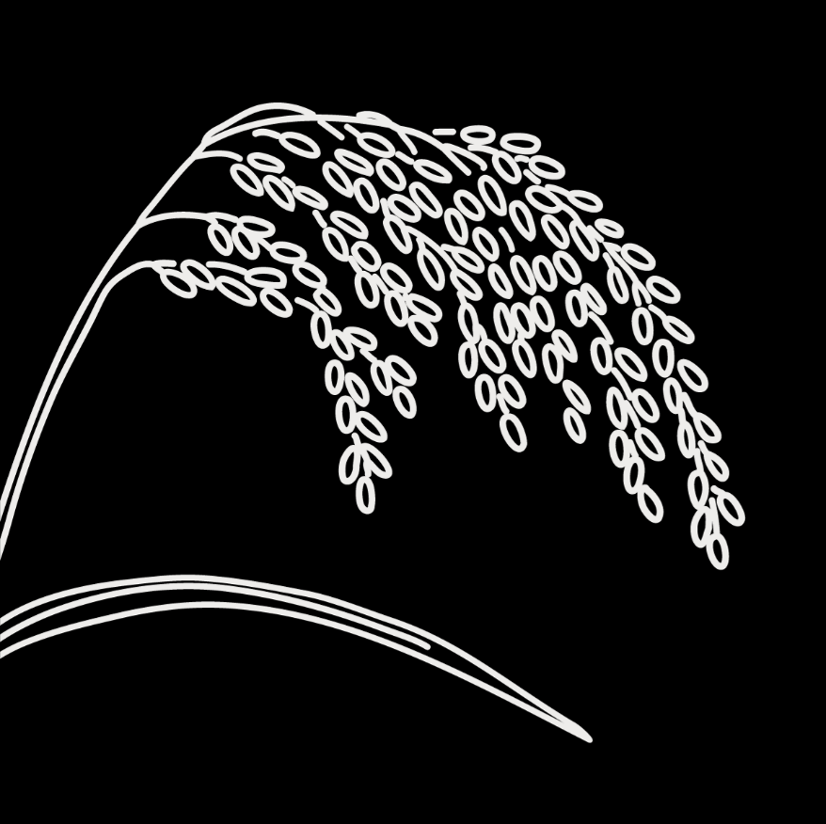
Genebanks and Seed Systems Toolkit
  - KII Checklist #6 – National and International Breeding Programs

Target group: These are guide questions for National and International Breeding Institutions (e.g., NAROs, CGIAR genebanks, etc.) engaged in plant breeding and variety release. The aim is to understand the breeders’ roles and activities in national seed systems, assess their strengths and weaknesses, and how their work is affected by governance and other factors. We also aim to understand their views on seed system development.

The interviewer should interview one or a few breeders who know the institution’s activities within the national seed system well and leadership.

Introduction
Explain the objective and obtain interviewee consent (fill out and attach the consent form for KIIs)

General information about the breeding program
- Can you explain the history and current focus of the breeding program?
  - Year of establishment
  - Change/expansion in focus over time
- How many varieties has your organization released (in total and average per year). (If available, request a list of the varieties)
- What are the financial sources of the organization?
  - Annual budget operational routines
  - External project/program funding and donors

Variety development and management
- What is the source of germplasm?
  - Do you use genebank materials? If yes, from which genebank? If not, why not?
- To what extent are your new varieties adopted by farmers? What are the successes/challenges in terms of adoption?
- What activities have you done to involve farmers in your breeding programs?
- Does your breeding program have (or is it in the process of obtaining) any plant variety protection (PVP) or patents?
- Please describe: why the PVP was sought, the process/actors involved, where the application was made, which varieties are protected, what rights the PVP/patents give your organization.

Seed production
- Which types of early generation seed (EGS) do you produce (e.g., breeder, pre-basic, basic seeds)?
- How are these seed production activities organized? Describe:
  - Land and other inputs you use
  - Seed production activities you outsource
  - Seed production monitoring and inspection controls for quality
  - Certification of these EGS (if any)
  - Seed storage processes and facilities
- What are the source seeds you use for multiplication, and how do you access them (if not your own)?
- Do you produce enough EGS to meet the needs and demands of other seed producers? Why/why not?(Fill out the table below for the last three seasons or get EGS production records if possible for filling the table later)

Table 1. The volume of EGS produced by breeding institutions
Year/season (start with the most recent) | Crop | Types of EGS | Quantity (Kg)

Dissemination
- Who are the users of your EGS?
  - Breeder seeds
  - Pre-basic seeds
  - Basic seeds
- What are the access conditions for different users, including the above users you mentioned?
  - Farmers’ organizations, e.g., seed producer cooperatives or unions
  - NGOs
  - Individual out-growers
  - Government seed companies
  - National private seed companies
  - International private seed companies
- Are there users who cannot access your EGS? If yes, which ones and why?
- How do users get information about the crops and their varietal traits of seeds you disseminate?
  - Information channel
  - Variety promotion strategies (if any)

Strengths and weaknesses
a) Overall, what are the main strengths and weaknesses of your breeding program?

Coordination with other actors
- Who are the main actors you work with?(check off all that apply)
- Genebanks
- Agricultural extension
- Farmer organizations, e.g., seed producer cooperatives
- Individual farmers
- NGOs
- Plant variety release committee and registration office
- New plant variety protection bureau
- Seed quality control agency and plant protection and quarantine authority
- Seed companies
- Others (specify):__________________________________
- How well do your interactions/collaborations with these actors function?
  - Are there any challenges in coordinating your activities with them?
  - How do you think these interactions can be improved?
- Do you work with the national genebank? If so, how?
  - Do you have suggestions on how the role of the national genebank can be improved?

Contextual factors
- Which government policies and regulations effectively support your plant breeding work? Which ones pose challenges? Please explain.
- Are there local customs, beliefs, or cultural practices that affect your seed-related work? How?
- What are the effects of the market/economy on your activities? Give specific examples

Recommendations
- Is there anything else you would like to share about your activities or how the seed system is functioning?
- In your view, what are the key issues related to seed in this country?
- Do you have any suggestions or recommendations on how to improve farmers’ access to sufficient, good quality seed of preferred crops and varieties?

