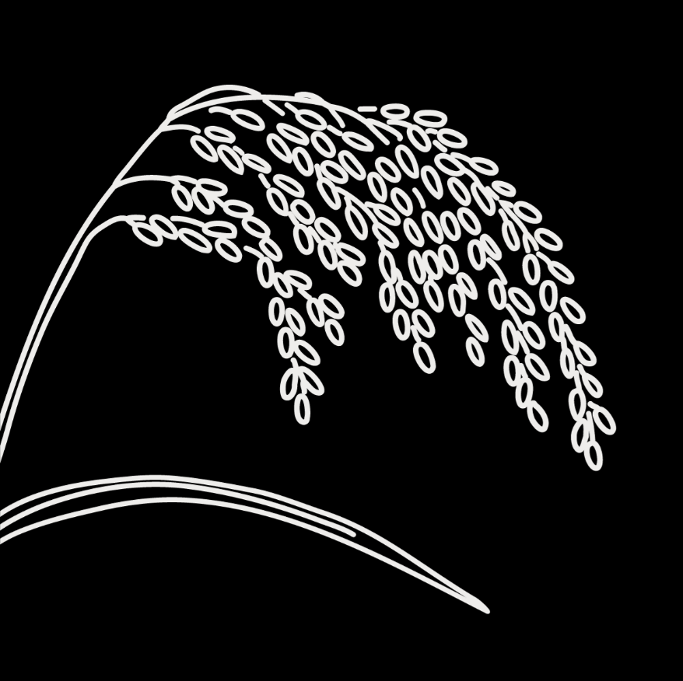
Genebanks and Seed Systems Toolkit
  - KII Checklist #5 – National and International Genebanks

Target group: These are guide questions for National and International Genebanks (e.g., CGIAR genebanks) located in the country that collect, conserve, characterize and evaluate germplasm for use by farmers, breeders, and other seed system actors. The aim is to understand the genebanks’ roles and activities in national seed systems, assess their strengths and weaknesses, and how these are affected by governance and other contextual factors. We also aim to understand their views on seed system development.

The interviewer should interview one or a few genebank experts who know the organization’s activities within the national seed system well. Such experts include people working on PGRFA ex-situ and in-situ conservation/ management, ITPGRFA focal persons, policy experts/staff working on access and benefit-sharing arrangements, and leadership.

Introduction
Explain the objective and obtain interviewee consent (fill out and attach the consent form for KIIs)

General information about the organization
- What is the goal of your genebank in general? And specifically in relation to seed?
- What is the mandate of the genebank?
- How many collections and accessions do you manage?
- How are you funded?
  - Approximate annual budget
  - Staff
  - External project/program funding and donors

Variety development and management
- What activities have you done to link ex-situ with in-situ/on-farm activities (if any)?
- Who are the users of your ex-situ collections/germplasm? (obtain germplasm distribution data, i.e., number of accessions/samples per crop obtained by users (i.e., farmers, NGOs, companies, breeders, universities, etc.) and year obtained.
- What are the access conditions for different users, including the above users you mentioned?
  - National stakeholders
  - International stakeholders residing in your country
  - Foreign actors outside your country
- Are there users who cannot access your germplasm collections? If yes, which ones and why?
  - Do you have suggestions on how to improve access?

Seed production and dissemination
- Do you engage in seed production and dissemination for crop production? Explain how.
- How do your activities contribute to the country’s seed systems?
  - Local or farmers’ seed system
  - Formal seed system

Strengths and weaknesses
- What are the main strengths and weaknesses of the genebank in the activities you have described? e.g.:
  - Capacity to characterize and multiply germplasm
  - System for germplasm distribution
  - Seed multiplication, viability, and safety

Coordination with other actors
- Who are the main actors in the seed system that you work or interact with? (check off all that apply)
- Plant breeders
- Agricultural extension service providers
- Farmers’ organization, e.g., community seed bank groups
- Local seed businesses or seed producer cooperatives
- Farmers
- NGOs
- Seed companies
- Others (specify):__________________________________
- How well do your interactions/collaborations with these actors function?
  - Are there any challenges in coordinating your activities with them?
  - How do you think these interactions can be improved?
- Do you have suggestions on how the role of the national genebank can be improved?

Contextual factors
- Which government policies and regulations effectively support your genebank’s work? Which ones pose challenges? Please explain.
- What is your assessment of the policy direction regarding access and benefit? Describe its historical development. What are the positive and negative aspects?
- Are there local customs, beliefs, or cultural practices that affect your genebank’s work? How?
- What are the effects of the market/economy on the genebank’s activities? Give specific examples.

Recommendations
- Is there anything else you would like to share about your activities or how the seed system is functioning?
- In your view, what are the key issues related to seed in this country?
- Do you have any suggestions or recommendations on how to improve farmers’ access to sufficient, good quality seed of preferred crops and varieties?

