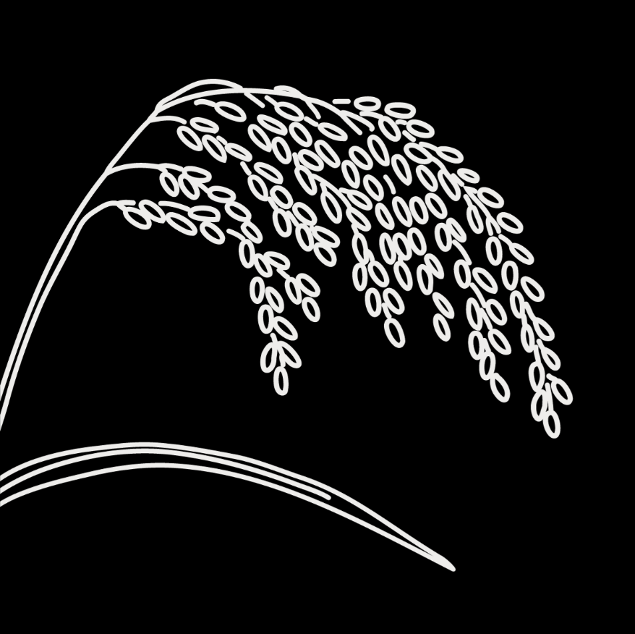
BOLD Genebanks and Seed Systems Toolkit
  - General information about the community
The following information should be collected for each community selected for FGDs. The data sources consulted should be clearly indicated below. Data sources can include secondary sources (publications, reports, etc) and/or key informants knowledgeable about the community (community leaders, local government officials, extension officers, etc). Copies of interviews and documents consulted should be kept in the project archives.
LOCATION
Name of community:
District:
Region/Province:
Country:
DEMOGRAPHY
Population (no. people):
% of the population engaged in farming:
Ethnolinguistic groups:
AGROECOLOGY
Elevation RANGE (m.a.s.l):
Average annual rainfall:
Average annual temperature:
Agroecological/climatic zone:
Climate hazards:
LIVELIHOODS
Main livelihood activities/sources of income:
Main agricultural production systems:
The average size of landholding (for farming):
Type of land tenure:
Access to irrigation:
CROPS cultivated in the community/area:
Cereals:
Root/Tubers:
Pulses/Legumes:
Vegetables:
Fruits:
Others:
INFRASTRUCTURE AND SERVICES
Description of road infrastructure, and public transport:
Nearby markets (location, distance in km, main products purchased/sold by farmers):
Access to agro-input dealers (name, location, distance in km, types of inputs sold):
Agricultural extension and research services/research stations active in the area:
Farmer groups and cooperatives in the area (name and main activities):
OTHER
Any other information about the community considered relevant to understand the community context:

